**© Biology 121, UNIVERSITY OF BRITISH COLUMBIA.**

**Practice Midterm**

**Midterm 2, March 2020**

|  |  |  |  |
| --- | --- | --- | --- |
| **Name** **:** |  |  |  |
|  | FAMILY NAME |  | FIRST NAME |

**Student Number :** _______________________________

**Instructions:**

1. Answer all questions in the space provided. The back of the exam will not be marked unless it is an exact replacement for material that is crossed out.

2. Writing can be in pencil or ink, but pencil or erasable ink answers **cannot** be remarked.

3. Answers may be in sentences or point form. Illustrations are acceptable but must be annotated.

4. Students suspected of any of dishonest practices will be immediately dismissed from the examination and will be subject to disciplinary action.

5. Other than **a one page** study sheet based on the provided template and a **non-programmable calculator**, no other memory devices are permitted.

6. Students may not speak or in any other way communicate with other students while in the examination room.

7. Students may not expose their written paper to other students. The excuse of accidental exposure, forgetfulness, or ignorance will not be accepted.

8. Make sure you have **7** written pages (3 pieces of paper) including this cover page.

**I have read and fully understand these instructions.**

**Student signature ______________________________________________________**

**Mark allocation**:

|  |  |  |  |  |  |  |
| --- | --- | --- | --- | --- | --- | --- |
|  |  |  |  | **Question** | **Marks possible** | **Your mark** |
|  |  |  |  |  |  |  |
|  |  |  |  |  |  |  |
|  |  |  |  |  |  |  |
|  |  |  |  |  |  |  |
|  |  |  |  | Concept Map | 1 |  |
|  |  |  |  | Total |  |  |

**1)** You are a scientist studying populations of field mice and effects of predation on the mice by hawks. These mice have a single gene that controls fur colour. Mice with the F allele have light brown fur, but mice with the f allele have black fur. F is dominant to f. In your study, there are two populations of mice, one that lives in a field with short, sparse grass; and another population that lives in a separate field with abundant tall grass. The population in the field with abundant tall grass is in Hardy-Weinberg equilibrium **(10 marks total).**

Data from mice in the field with short, sparse grass. Data from mice in field with abundant tall grass not shown.

|  |  |  |  |
| --- | --- | --- | --- |
| Genotype | Observed | Observed frequencies | Predicted frequencies |
| FF | 55 | 0.385 |  |
| Ff | 85 | 0.594 |  |
| ff | 3 | 0.021 |  |

a) What are the respective frequencies of the ‘F’ and ‘f’ alleles in the population of mice found in the field with short sparse grass? Show your calculations for full credit, and show your answers to at least two decimal places. (**2 marks**)

b) Based on the data you collected, is the population of mice found in the open field with short sparse grass in Hardy-Weinberg equilibrium? Show your work and briefly justify your answer. (**4 marks**)

c) Based on specific information given in the question, provide brief reasoning that supports your answer to ‘part b’. With specific reference to the scenario and possible evolutionary mechanisms, provide an explanation for why the population of mice found in the field with short, sparse grass is, or is not in Hardy-Weinberg equilibrium. (**4 marks**)

**2)** The figure below is a simplified phylogeny of the Chordates, a group of animals belonging to phylum Chordata that includes mammals, reptiles, fishes, tunicates (sea squirts) and more. Numbers refer to nodes, letters refer to taxa and lines indicate when a trait first evolved. (**11 marks total**)

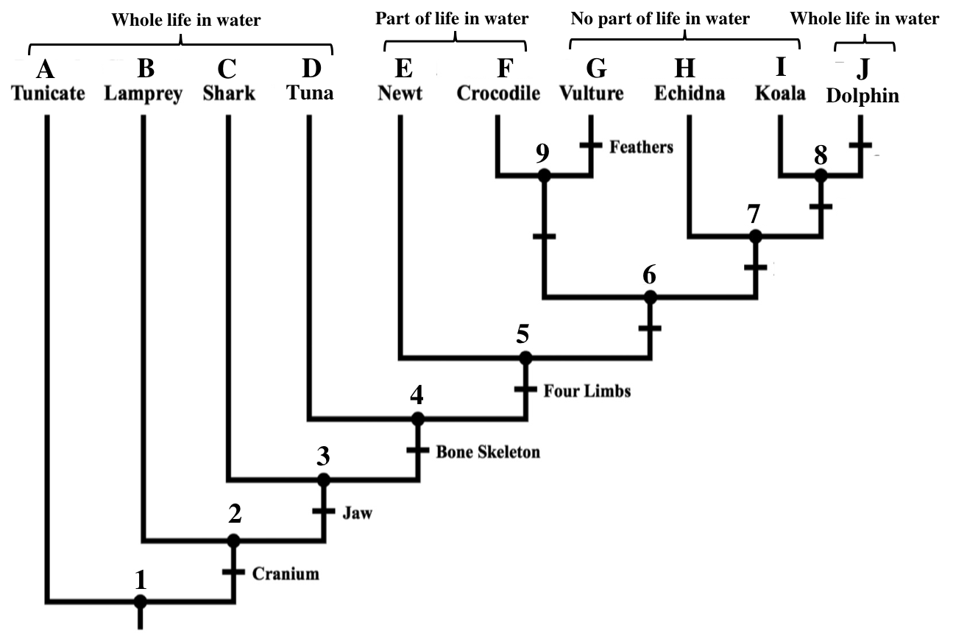

a) The table below lists a selection of traits found in some Chordates. An “X” tells you whether a species has a trait. On the phylogeny, label where the gizzard and amnion evolved, applying the principle of parsimony. (**2 marks**)

|  |  |  |
| --- | --- | --- |
|  | Gizzard | Amnion |
| vulture | X | X |
| crocodile | X | X |
| echidna |  | X |
| dolphin |  | X |
| koala |  | X |
| newt |  |  |

b) Fill in the blanks below.

Node **____** represents the most recent common ancestor of the **echidna** and **crocodile**. (**0.5 marks**)

Node **____** represents the most recent common ancestor of the **lamprey** and the **tuna**. (**0.5 marks**)

c) Draw a circle around one monophyletic group (clade) on the phylogenetic tree.

Explain how you can tell it is monophyletic. (**2 marks**)

d) According to the phylogenetic tree, did **koalas** and **dolphins** evolve from **echidnas**? Explain your answer.   
(**2 marks**)

e) According to the phylogenetic tree, which of these two taxa is more closely-related to the **shark**?

Lamprey / Koala / Equally Related (circle one).

Explain your answer below, making reference to **specific nodes** on the phylogenetic tree. (**2 marks**)

f) Is a life spent entirely in water likely to be a homologous trait for **tuna** and **dolphins**? (yes or no).   
Explain your reasoning, and make reference to **specific nodes** on the phylogenetic tree (**2 marks**)

**Q3)** **11 marks total.** The table below lists different traits found in a selection of plants. An “X” tells you that a genus has a trait (X=present, blank=absent). Each table row is a plant genus and each table column is a trait. Each genus and trait has an associated number or letter, which you may use instead of writing out the full genus/trait name.

**2a)** **6 marks.** Using the information in the table, create a phylogeny of these plants in the space provided below. Then, using the principle of parsimony, indicate where each trait arose using clear hash marks along the phylogenetic tree.

|  |  |  |  |  |  |
| --- | --- | --- | --- | --- | --- |
| Plant genus | Produces seeds (**A**) | Produces flowers (**B**) | Vascular tissue (**C**) | One embryonic leaf (**D**) | Scale-like leaves (**E**) |
| *Thuja* **(1)** | X |  | X |  | X |
| *Musa* **(2)** | X | X | X | X |  |
| *Polystichum* **(3)** |  |  | X |  |  |
| *Helianthus* **(4)** | X | X | X |  |  |
| *Pseudotsuga* **(5)** | X |  | X |  |  |

Draw your phylogeny here.

**2b)** **1 mark.** Circle the node indicating the most recent common ancestor of *Pseudotsuga* (5)and *Musa* (2)*.*

**2c)** **1 mark.** On your tree, put a star (*) next to the synapomorphy for the clade containing all five taxa.

**2d)** **1 mark.** Draw a circle around one monophyletic group. Explain why it is monophyletic.

**2e)** **2 marks.** Based on your phylogenetic tree, would you expect the *Thuja* genome to be more similar to the *Helianthus* genome, or to the *Polystichum* genome? Briefly explain your answer.

**4)** The figures below show two species of bear. Brown bears (*Ursus arctos*) are generally smaller and lighter of the two (1.5-2.8 m long, 220 kg) and most have brown coats, short faces and larger ears. They are found in diverse habitats such as forests and meadows and eat both plants and many kinds of animals. Polar bears (*Ursus maritimus*) are larger (2-3 m long, 450 kg), have coats that appear white, longer faces and smaller ears. They thrive in arctic environments, and are completely carnivorous, eating prey such seals and walruses. In occasions when their ranges overlap, brown bears and polar bears can mate and produce viable hybrid offspring. **(13 marks total)**

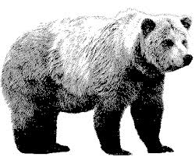 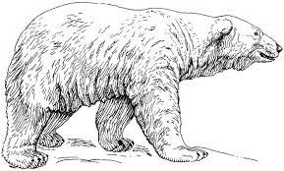

Brown bear (*Ursus arctos*) Polar bear (*Ursus maritimus*)

a. Which species concept (choose only one) would justify the classification of brown bears and polar bears as one species? Explain your answer using only the information provided. (**2 marks**)

b. Under which species concept (choose only one) would polar bears and brown bears be considered two species? Explain your answer using only the information provided. **(2 marks)**

c. What specific evidence would a biologist need to determine that brown bears and polar bears were different species using the phylogenetic species concept? Explain how this evidence would allow them to make their decision. **(3 marks)**

d. Suppose there is a population of brown bears in the mountains of central British Columbia [mountain bears] which form a sister clade to the brown bears of northern coastal British Columbia [coastal bears]. The coastal bears specialize on a marine diet such as whale carcasses, clams and salmon.

Describe the process of a large, single species of BC brown bears becoming two species: mountain brown bears and coastal brown bears. Explain what could happen during each step, each one leading to the next, to cause this result.

Use the biological species concept and include references to appropriate evolutionary mechanisms in your answer, and be as specific as possible. **(6 marks)**

|  |
| --- |
| Step 1 |
| Step 2 |
| Step 3 |

**4)** Red-billed quelas are common birds in parts of Africa. These birds make nests and breed in large, very dense colonies. A male and a female mate and occupy a shared nest to raise offspring. During the year, both male and female birds have identical light brown coloration. (**13 marks total**)

During the breeding season, males produce more colorful feathers ranging from red to yellow. Red and yellow pigments come from the bird’s food. It was assumed birds with red feathers had a more nutritious diet than birds with yellow feathers.

Biologists have hypothesized that female quelas may prefer to mate with males that have red feathers.

a) Based on all of the information above, briefly explain the reasoning underlying this hypothesis. Your answer should make specific reference to the fitness effect of female choice on female fitness (females who choose males with red feathers compared with females that choose males with yellow feathers). (**6 marks**)

Decades later, James Dale studied coloration in quelas. He found that the male plumage color is highly correlated with the plumage color of their father. The birds’ diet did not affect coloration after all. All birds have the same average number of offspring regardless of their feather color.

b) Your friend suggests that the feather coloration (red vs. yellow) in red-billed quelas indicates that sexual selection is occurring and feather coloration is a signal used by females to evaluate male quality. Do you agree with his claim? (**1 mark**)

**Yes / No** (circle one)

c) Explain why or why not with specific reference to each of the three main criteria required for selection.   
**(6 marks**)

|  |  |
| --- | --- |
| Criteria for Selection | Explanation |
|  |  |
|  |  |
|  |  |